**12. Earley Parser for Context-Free Grammars**

**Aim:**  
To implement an Earley parser for context-free grammars.

**Algorithm:**

1. Define a context-free grammar.
2. Use NLTK’s EarleyChartParser for parsing.
3. Parse the sentence and display the results.

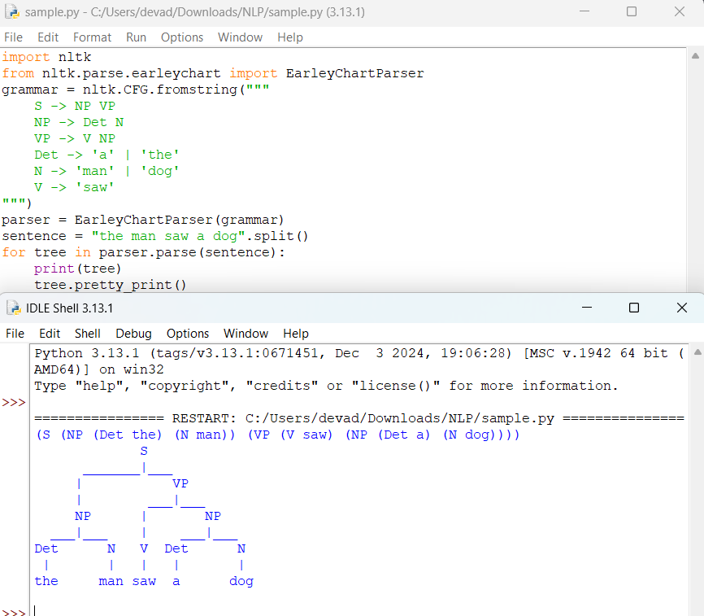

**Result:**  
The Earley parser successfully parses the sentence using the CFG.